

***Home For Sale Casa Lomas 1 BR 1 Bath***

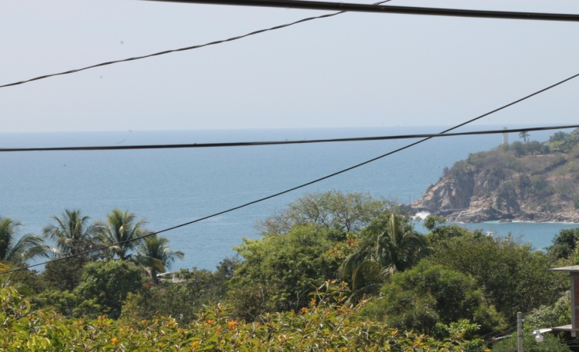

***The Space****: This Small fixer upper offers much opportunity to create your dream home with spectacular views. The property is priced to sell.*

***The Neighborhood****: This property is located in the colonia Lomas, on the very top of the hill with beautiful views of the pacific ocean, and good schools.*

***Lot:*** *227 Mt2*

***Constrution:*** *80 Mt2*

*Offered @ 78,500 USD*

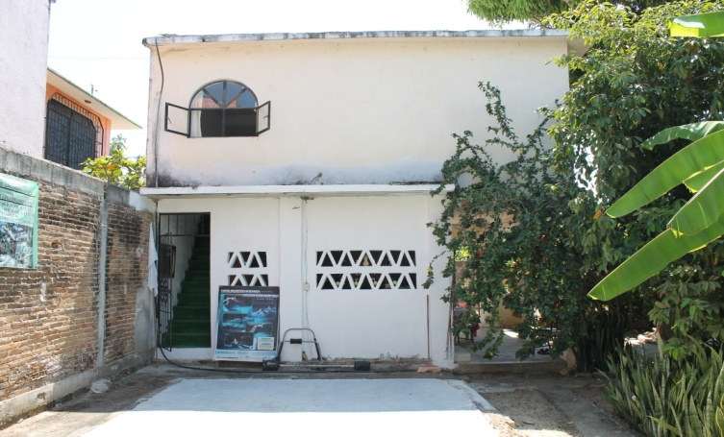

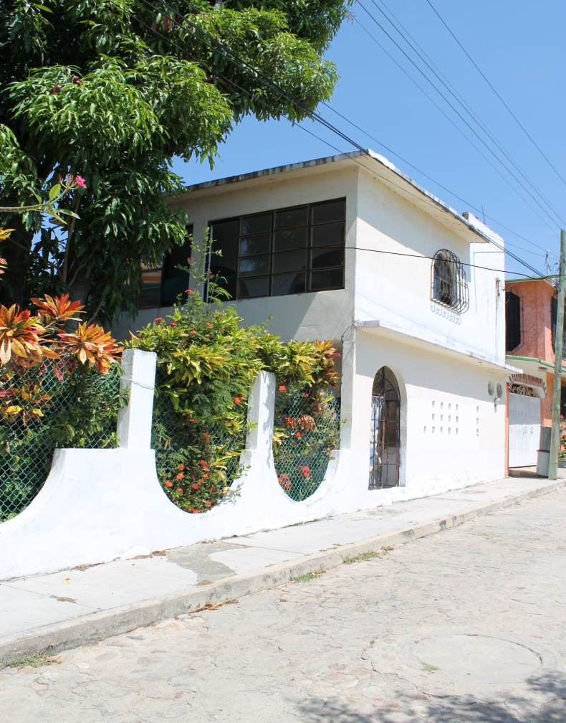

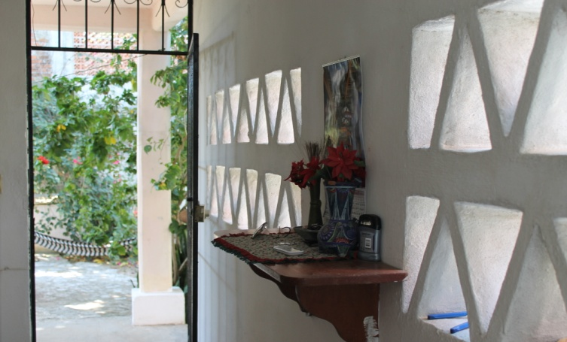

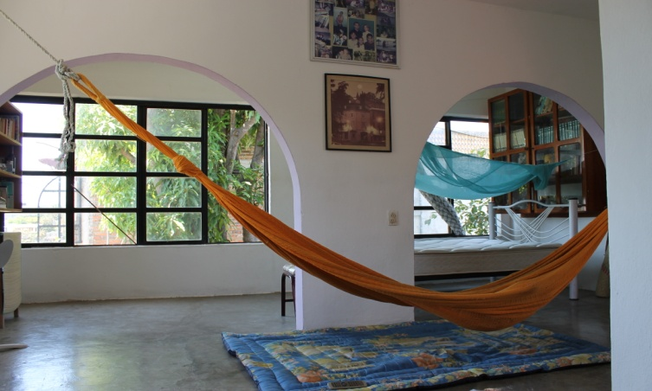



Scott Sousa Senior Sales Manager

Phone: (954) 915-5526

Email: scott_sousa@yahoo.com

Web: SunsetRealtyPuerto.com

Facebook: Sunset Realty